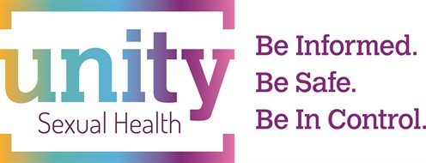
Sexual and Reproductive Health Update
Holiday Inn, Filton

Tuesday 14 May 2019

Save the date – booking opens soon

Programme

CHAIR Mr Michael Clarke, Senior Health Advisor, Unity Sexual Health, Central Clinic, Tower Hill, Bristol

09:00 – 09:20 Registration and coffee

09:20 – 10.00 An interesting year for STIs in Bristol - Dr Lindsey Harryman, Consultant GUM and HIV, Unity Sexual Health, Central Clinic, Tower Hill, Bristol

10.00 – 10.40 BASHH updates – Dr Sophie Ramsden, ST3, Unity Sexual Health, Central Clinic, Tower Hill, Bristol

10.40 – 11.10 COFFEE

11:10 –11.50 Contraception Updates – Dr Freddie Von-Hawrylak, ST3, Unity Sexual Health, Central Clinic, Tower Hill, Bristol

11.50 – 12:30 Concerns for adolescents, to include FGM, vulval appearance, vaginal discharge – Dr Naomi Crouch, Consultant Gynaecologist, St Michael’s

12:30 – 13:30 LUNCH

13:30 – 14:10 Breakout Session 1
- Implant Workshop – Sharon Moses, Manika Singh, Emma Trump
- Emergency Contraception - Dr Katherine Kearley-Shiers
- Psychosexual issues in Men – Sally Soodeen
- Young people and consent issues- Brook

  - – 14:55 Breakout Session 2
- Implant Workshop – Sharon Moses, Manika Singh, Emma Trump
- Emergency Contraception - Dr Katherine Kearley-Shiers
- Psychosexual issues in Men – Sally Soodeen
- Young people and consent issues- Brook

15.00 – 15.20 COFFEE

15.20 – 16.00 Hormones and Thrombo-embolism – Amanda Clark, Consultant Haematologist, Haematology and Oncology Centre, Bristol

16:00 END

